Discussion Assignment 1
In a school scenario, the head academics wants to analyze the students enrolled in different I.G.C.S.E courses, categorized under either sciences or humanities subjects. The sets were as follows:
A={John, Mary, June Peter, Godfrey}.
B={June, Eunice, Peter, Ken}.
U={John, Mary, Peter, Godfrey, June, Eunice, Ken, Joyce, Tom}.
The sets above were represented in a Venn diagram as follows:
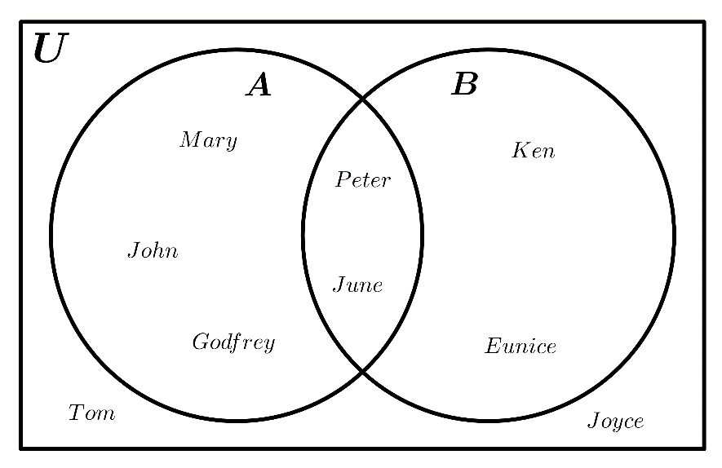
Analysis of the sets above were as follows:
i. A ∪ B={John, Mary, Peter, Godfrey, June, Eunice, Ken}.
ii. A ∩ B={Peter, June}.
iii. (A ∩ B) ∪ U={Peter, June, Joyce, Tom}.
iv. The Power set of A.
P(A)={∅,{John},{Mary},{June},{Peter},{Godfrey},{John,Mary},{John,June},{John,Peter},{John,Godfrey},{Mary,June},{Mary,Peter},{Mary,Godfrey},{June,Peter},{June,Godfrey},{Peter,Godfrey},{John,Mary,June},{John,Mary,Peter},{John,Mary,Godfrey},{John,June,Peter},{John,June,Godfrey},{John,Peter,Godfrey},{Mary,June,Peter},{Mary,June,Godfrey},{Mary,Peter,Godfrey},{June,Peter,Godfrey},{John,Mary,June,Peter},{John,Mary,June,Godfrey},{John,Mary,Peter,Godfrey},{John,June,Peter,Godfrey},{Mary,June,Peter,Godfrey},{John,Mary,June,Peter,Godfrey}}
v. A’ ={Eunice, Ken, Joyce, Tom}.
vi. ∅∩B=∅
vii. A × B = {(John,June),(John,Eunice),(John,Peter),(John,Ken),(Mary,June),(Mary,Eunice),(Mary,Peter),(Mary,Ken),(June,June),(June,Eunice),(June,Peter),(June,Ken),(Peter,June),(Peter,Eunice),(Peter,Peter),(Peter,Ken),(Godfrey,June),(Godfrey,Eunice),(Godfrey,Peter),(Godfrey,Ken)}
viii. A-B={John, Mary, Godfrey}.
ix. (A – B)∪ (B – A)= {John, Mary, Godfrey}∪{Eunice, Ken}
={John, Mary, Godfrey, Eunice, Ken}
x. Prove any one De Morgan identity for A and B.
According to De Morgan’s identity, (AUB)'=A'nB'. Since (AUB)^'={Tom, Joyce} and A'nB'={Tom, Joyce}, we therefore conclude that the identity is true.

